PIZZA SALES SQL QUERIES

A. KPI’s :
1.Total Revenue :
SELECT SUM(total_price) AS Total_Revenue FROM pizza_sales

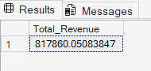

2.Average Order Value :

SELECT SUM(total_price) / COUNT(DISTINCT order_id) AS Avg_Order_Value
FROM pizza_sales

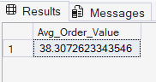

3.Total Pizza Sold :

SELECT SUM(quantity) AS Total_Pizza_Sold FROM pizza_sales

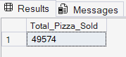

4.Total Orders :

SELECT COUNT(DISTINCT order_id) AS Total_Orders FROM pizza_sales

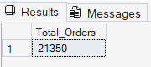

5.Average Pizza Per Order :

SELECT CAST(CAST(SUM(quantity) AS DECIMAL(10,2)) /
CAST(COUNT(DISTINCT order_id) AS DECIMAL(10,2)) AS DECIMAL(10,2)) AS Average_Pizza_Per_Order FROM pizza_sales
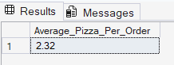

B. Daily Trend For Total Orders :

SELECT DATENAME(DW, order_date) AS Order_Day,COUNT(DISTINCT order_id) AS Total_Orders
FROM pizza_sales
GROUP BY DATENAME(DW, order_date)

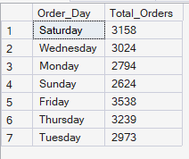

C. Monthly Trend For Total Orders :

SELECT DATENAME(MONTH, order_date) AS Month_Name,COUNT(DISTINCT order_id) AS Total_Orders
FROM pizza_sales
GROUP BY DATENAME(MONTH, order_date)
ORDER BY Total_Orders DESC

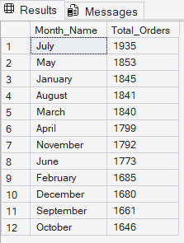

D. Hourly Trend For Total Orders :

SELECT DATEPART(HOUR, order_time) AS Order_Hours,COUNT(DISTINCT order_id) AS Total_Orders
FROM pizza_sales
GROUP BY DATEPART(HOUR, order_time)
ORDER BY DATEPART(HOUR, order_time)

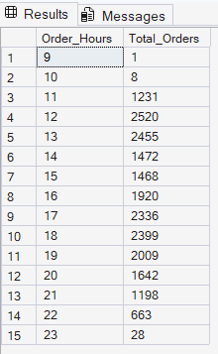

E. % Of Sales By Category :

SELECT pizza_category,CAST(SUM(total_price) AS DECIMAL(10,2)) AS Total_Revenue,
CAST(SUM(total_price * 100) / (SELECT SUM(total_price) FROM pizza_sales)
AS DECIMAL(10,2)) AS PCT
FROM pizza_sales
GROUP BY pizza_category

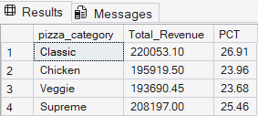

F. % Of Sales By Pizza Size :

SELECT pizza_size,CAST(SUM(total_price) AS DECIMAL(10,2)) AS Total_Revenue,
CAST(SUM(total_price * 100) / (SELECT SUM(total_price) FROM pizza_sales)
AS DECIMAL(10,2)) AS PCT
FROM pizza_sales
GROUP BY pizza_size
ORDER BY pizza_size

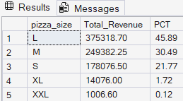

G. Total Pizzas Sold By Pizza Category :

SELECT pizza_category,SUM(quantity) AS Total_Quantity_Sold
FROM pizza_sales
GROUP BY pizza_category
ORDER BY Total_Quantity_Sold DESC

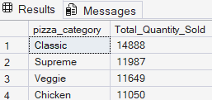

H. Top 5 Pizzas By Revenue :
SELECT TOP 5 pizza_name,SUM(total_price) AS Total_Revenue
FROM pizza_sales
GROUP BY pizza_name
ORDER BY Total_Revenue DESC

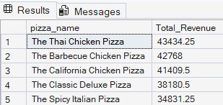

I. Bottom 5 Pizzas By Revenue :
SELECT TOP 5 pizza_name,SUM(total_price) AS Total_Revenue
FROM pizza_sales
GROUP BY pizza_name
ORDER BY Total_Revenue

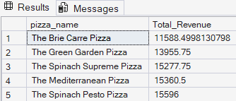

J. Top 5 Pizzas By Quantity :
SELECT TOP 5 pizza_name,SUM(quantity) AS Total_Quantity_Sold
FROM pizza_sales
GROUP BY pizza_name
ORDER BY Total_Quantity_Sold DESC

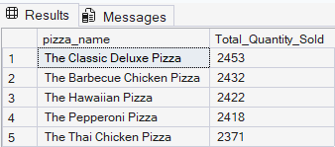

K. Bottom 5 Pizzas By Quantity :
SELECT TOP 5 pizza_name,SUM(quantity) AS Total_Quantity_Sold
FROM pizza_sales
GROUP BY pizza_name
ORDER BY Total_Quantity_Sold

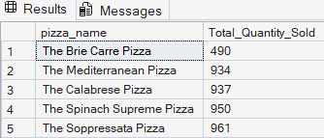

L. Top 5 Pizzas By Total Orders:

SELECT TOP 5 pizza_name,COUNT(DISTINCT order_id) AS Total_Orders
FROM pizza_sales
GROUP BY pizza_name
ORDER BY Total_Orders DESC

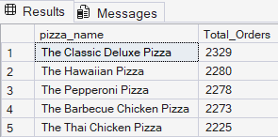

M. Bottom 5 Pizzas By Total Orders:
SELECT TOP 5 pizza_name,COUNT(DISTINCT order_id) AS Total_Orders
FROM pizza_sales
GROUP BY pizza_name
ORDER BY Total_Orders

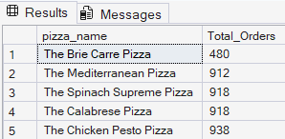

Note :
If you want to apply the pizza_category filters to the above queries you can use WHERE clause. Follow some of below example,
SELECT Top 5 pizza_name, COUNT(DISTINCT order_id) AS Total_Orders
FROM pizza_sales
WHERE pizza_category = 'Classic'
GROUP BY pizza_name
ORDER BY Total_Orders ASC
